- Title:
Encrypted Network Traffic Analysis for VPNs
- Short Rationale of FYP:
The adoption of network encryption is rapidly growing because traditional malware detection systems (i.e. inspecting unencrypted traffic) are becoming obsolete. Common social instant messaging apps such as WhatsApp, Facebook Messenger, Signal, WeChat, etc., employ end-to-end encryption protocols to ensure secure communication and safeguard user privacy. On the other side, a significant portion of malware spreads through encrypted network traffic, exploiting these protocols to conceal its activities. Generally, encrypted network traffic analysis is consisting of a broader spectrum to investigate the applications identifications, network intrusion detection, and user privacy (figure 1) ¹. However, there is limited research on the identification of internal activities of applications through encrypted network traffic especially for social media applications. There is a need to investigate the encryption strategies for current state-of-the-art network traffic for analysis and inspection.
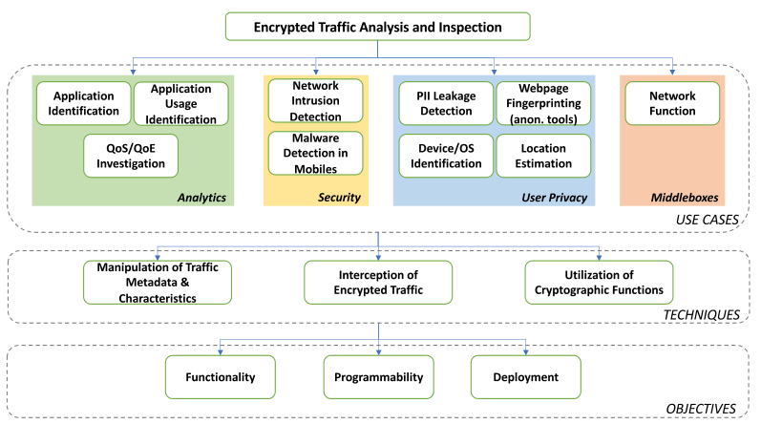
Figure 1
This study aims to investigate the encrypted network traffic employed by social media applications for identifying the supported features/activities (e.g. photo, video streaming, audio, text, etc.), protocol identification, and involved servers. In the proposed methodology, traffic capturing will be conducted through Android-based mobile devices and Wi-Fi access as shown in Figure 2. Different social media applications will be installed on devices and will be connected to the internet through a wireless access point. All the internet traffic of the wireless access point will be routed through a PC-based firewall to filter out the respective applications. For network traffic analysis, Wireshark and other latest software will be employed to monitor the encrypted traffic through analysis of the trace files. It is noteworthy that the IP addresses and ports are in plaintext while the payloads are in encrypted format for the sake of secrecy and privacy services. The IP addresses, ports, and packet patterns will be exploited to determine the behaviors of apps. The expertise gained through this project will help to design an encrypted network traffic analyzer module for the identification of social media applications with their internal activities.
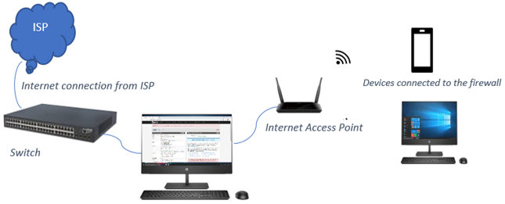
Figure 2:

- Major Objectives:
- The objective of this study is to investigate the challenges in inspecting network traffic when it is encrypted or tunneled.
- Identify and explore the various use cases and applications of encrypted traffic analysis.
- Gain a comprehensive understanding of the analysis of the encrypted network traffic.

- Outcomes of the FYP:
- 1x high-quality publication

- A basic encrypted network traffic analysis module that can distinguish the types of social media applications with their use cases.

- Major Equipment Required:
- 1x Laptop (Available in NUST)
- Wireshark, firewalls, and Mobile resources (Available in NUST)

- Possibility of Commercialization:
- Proof of concept under the proposed study can be extended by any organization working in the domain of encrypted network analysis.

- End-user(s) Keen to Adopt the FYP Results:
- The proposed encrypted analyzer module can be installed in an organization at the network administrator level to identify the usage of social media applications and especially the identification of its internal features in encrypted traffic.

